**Target Audience:** Scientists, sonographers & radiologists developing obstetric MRI.

**Purpose:**

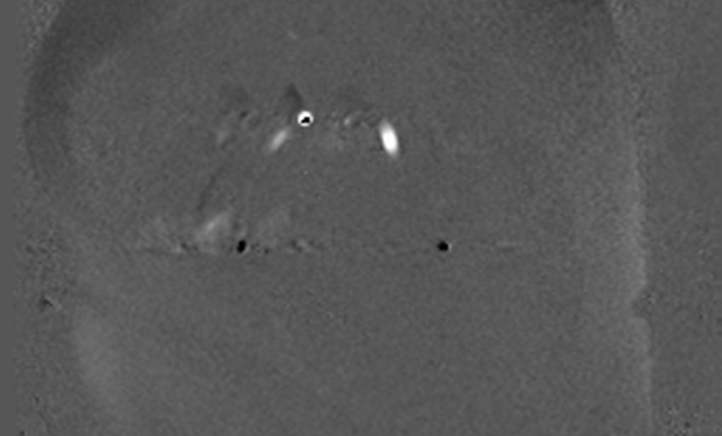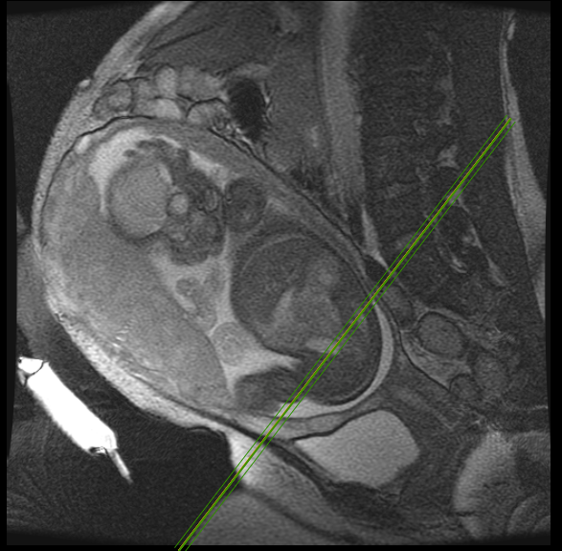

A

B

Figure 1: (A) Line indicates the position of the oblique coronal phase contrast acquisition (B) which demonstrates the iliac vessels (vertical arrows) and the uterine arteries (horizontal arrows)

Doppler ultrasound is widely used in obstetrics to predict conditions such as pre-eclampsia and intrauterine growth restriction (IUGR). These are related to abnormal placentation and are often associated with high resistance utero-placental blood flow1. The uterine artery pulsatility index (PI) and resistivity index (RI) are used routinely as markers of increased resistance to blood flow in the placenta2.MRI is now routinely used in obstetrics for fetal neurological assessment Although established for evaluating placental localisation and abnormalities, such as placenta accreta, there is limited research regarding placental blood flow. Early studies found that identification of the uterine arteries was difficult making further evaluation of flow impractical3. The aim of this work was to evaluate in a cohort of healthy women whether the uterine arteries could be identified at MR examination. Also if an RI and PI could be measured using phase contrast methods, and to compare these markers with those obtained at same day routine sonographic Doppler assessment.

**Methods and materials:**

The study was ethically approved. 35 normal singleton pregnancies at 28-32 weeks gestation were recruited, and underwent routine Doppler examination, followed by MRI examination. *Doppler US* was performed using a GE Voluson E8 (GEHC, Waukesha, WI) machine and, using inbuilt software, the RI and PI of both the left and right uterine arteries were measured. *MRI* was performed using an 8 channel cardiac array and a 1.5T MRI system (DV450 GEHC, Waukesha, WI). Following sagittal FIESTA breath-hold imaging, a cardiac gated cine phase contrast study was performed. Using both the magnitude and phase images, vessels in the uterine wall that passed orthogonally to the image plane, and with flow in the superior direction, were identified as likely uterine arteries. Exclusions were made if an artery could not be identified or if severe flow aliasing occurred. An in-house flow analysis program was used to delineate the vessel margin and measure RI and PI. These were then compared with the US results using Bland Altman statistics.

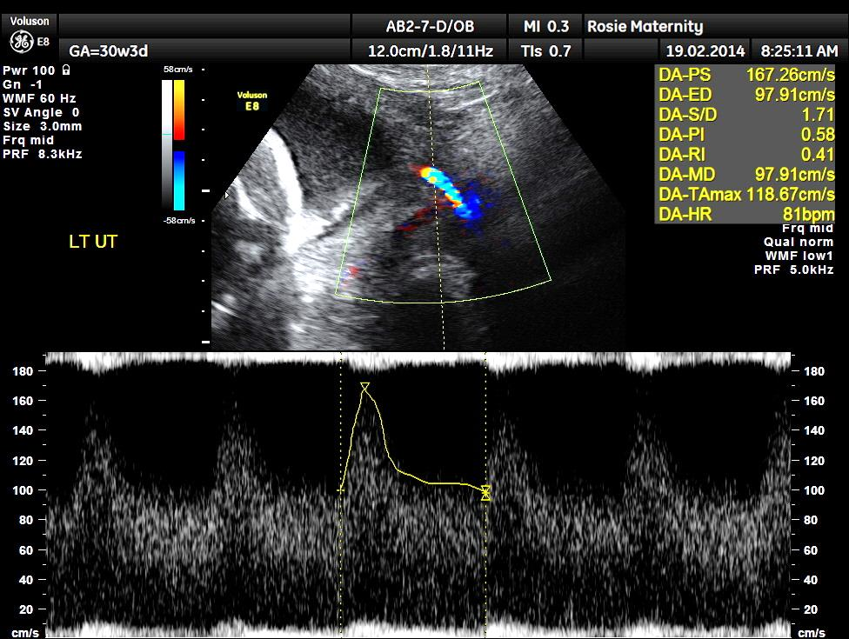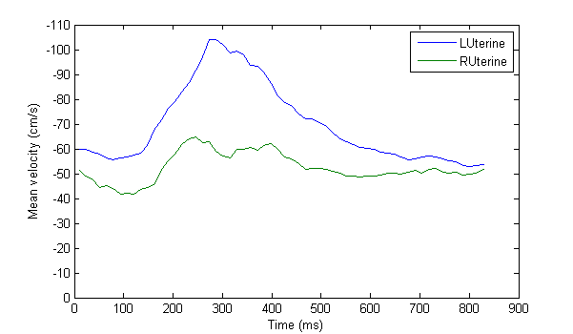

Figure 2: Example duplex Doppler US exam of a uterine artery with matching MRI flow profile superimposed in the bottom right hand corner.

**Results:**

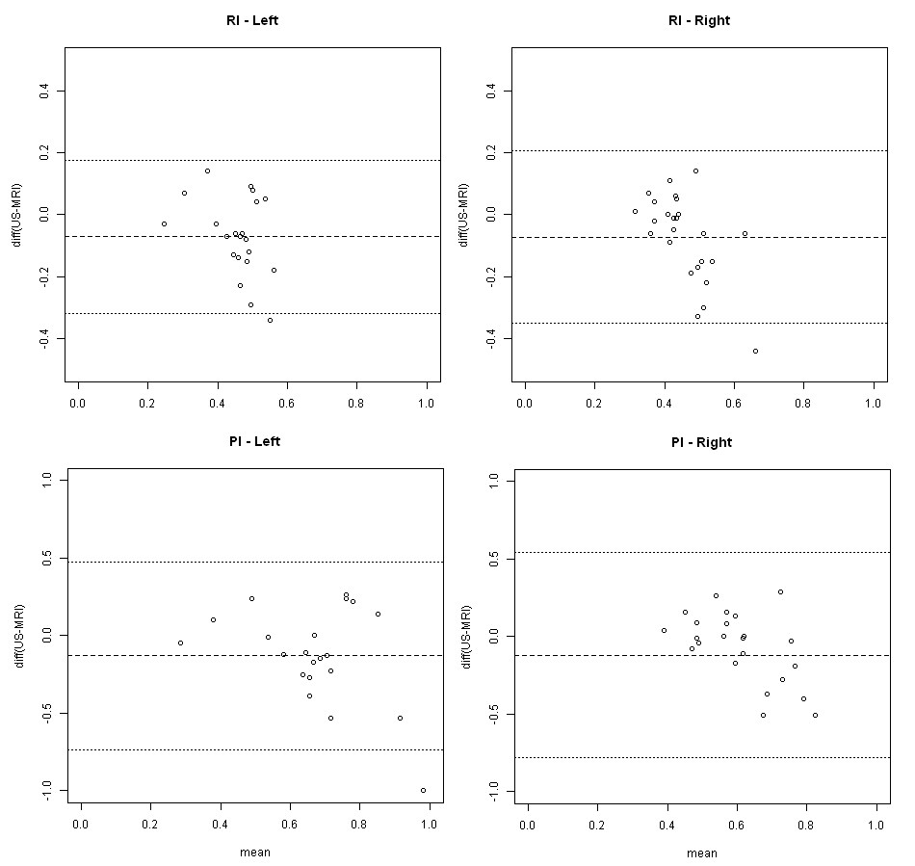

Figure 3: Bland-Altman plots for the comparison of RI and PI for the left and right uterine arteries.

At MRI 76 arteries were identified. At US one artery was not identified leaving 69 arteries for comparison. Of these 6 were excluded leaving 69 vessels in 34 patients for analysis. Bland-Altman analysis demonstrated in Figures 3 & 4 demonstrates a relatively small bias for the results.

**Discussion:**

Using a carefully selected imaging plane corresponding to the location used for ultrasound, it proved possible to identify uterine arteries in the majority (80%) of patients. Despite the examinations taking place within 90 minutes of each other, the correlation is only moderate for RI/PI. An issue with MRI based flow measurements is accurate background correction selection of an optimal V*enc.* MR phase contrast techniques also allow for absolute flow quantification, and with improved spatial resolution and a correspondingly longer acquisition time, total uterine blood flow may be obtained using this approach - a measurement that is currently considered unreliable using Doppler US.

**Conclusion:**

This study demonstrates that the uterine arteries can be identified at MRI in a majority of healthy pregnancies in the early third trimester, with a relatively small measurement bias when compared with same day Doppler US measurements. Future studies involving patients with abnormal Doppler findings are needed to further validate this MR based technique.

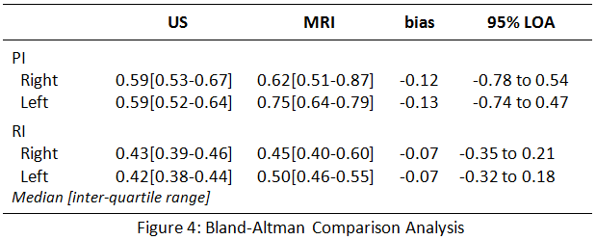

**References:**

1. Albaiges G, Missfelder-Lobos H, et al (2003) “Comparison of colour Doppler uterine artery indices in a population at high risk for adverse outcome at 24 weeks’ gestation” 2003 Ultrasound in Obstetrics and Gynaecology 2003; 21: 170-173

2. Stampalija T, Gyte G. M and Alfirevic Z “Utero-placental Doppler ultrasound for improving pregnancy outcome” Cochrane Database Systematic Review 2010;8 (9) CD008363

3. Pates J. A, Hatab M. R, et al. “Determining uterine blood flow in pregnancy with magnetic resonance imaging” Magnetic Resonance Imaging 2010; 28 : 507-510