A Rare Case of Post- partum Secondary Amenorrhoea
B Guruwadayarhalli*, N Nunes
West Middlesex University Hospital NHS Trust
A 29 year lady presented to A&E with secondary amenorrhoea, lower abdominal pain and feeling unwell 10 weeks post ventouse delivery and episiotomy repair. Vulva and vagina were reported to be friable at the procedure. She was breast feeding. The patient’s husband gave a history of difficulty having sexual intercourse and described feeling an obstruction. Patient’s urine pregnancy test was negative.
Pelvic examination was impossible as patient was very tender and the vaginal introitus appeared completely occluded. Abdominal ultrasound scan revealed a large haematocolpos, haematocervix and haematometra. A trans-perineal scan showed vagina to be completely occluded about one centimetre from the introitus. A trans-rectal ultrasound scan performed demonstrated a large haematocolpos and ruled out any further septations or occlusions further up in the vagina. Both ovaries appeared normal.
Patient underwent and EUA and incision of occlusion and drainage of vaginal collection and discharged home on combined oral contraceptive pills. At follow up two weeks post-operatively she was still unable to have sexual intercourse and advised to use vaginal dilators to prevent further recurrence. Abdominal pelvic ultrasound scan was essentially unremarkable with complete resolution of haematocolpos and haematometra.
Discussion:
Secondary amenorrhoea due to vaginal obstruction is very rare. Cases of haematocolpos have been described after Stevens – Johnson syndrome (Murphy and Brant 1998) and bone marrow transplantation (Tauchmanova et al. 2004; DeLord et al. 1999). In cases where they occur after bone marrow transplantation, they are thought to represent a manifestation of chronic graft vs host disease.

Cases reported are commonly from Africa. It may occur rarely as complication of female circumcision (Davis et al. 1999) or more commonly from chemical vaginitis (Arowojolu et al. 2001; Uchil et al. 2006).
Our case was unusual as a post instrumental delivery complication.

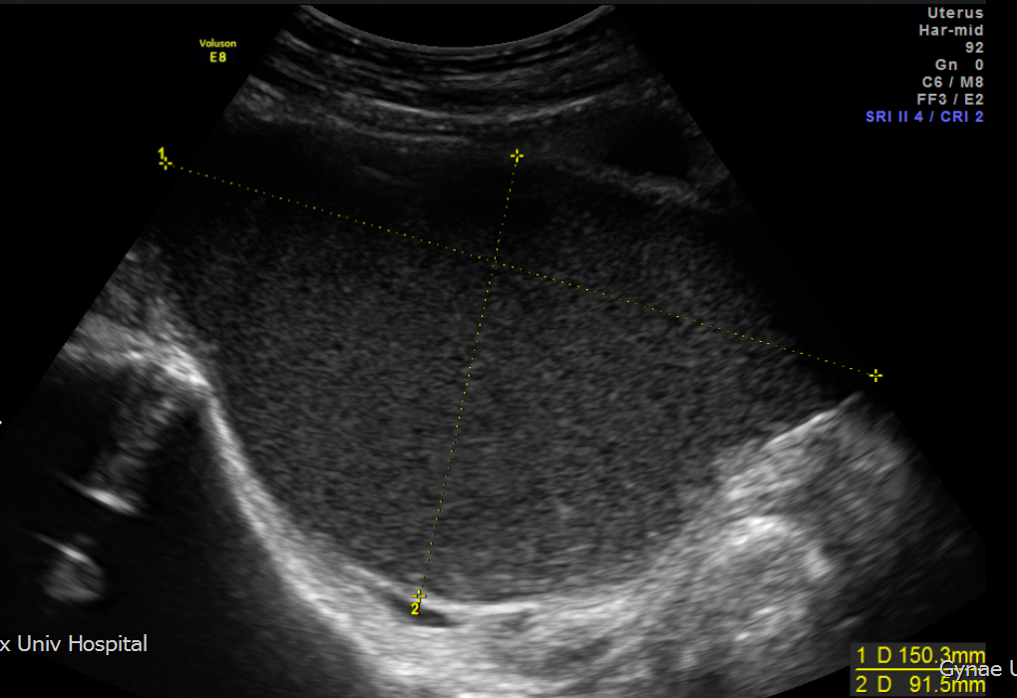 Haematocolpos Axial view
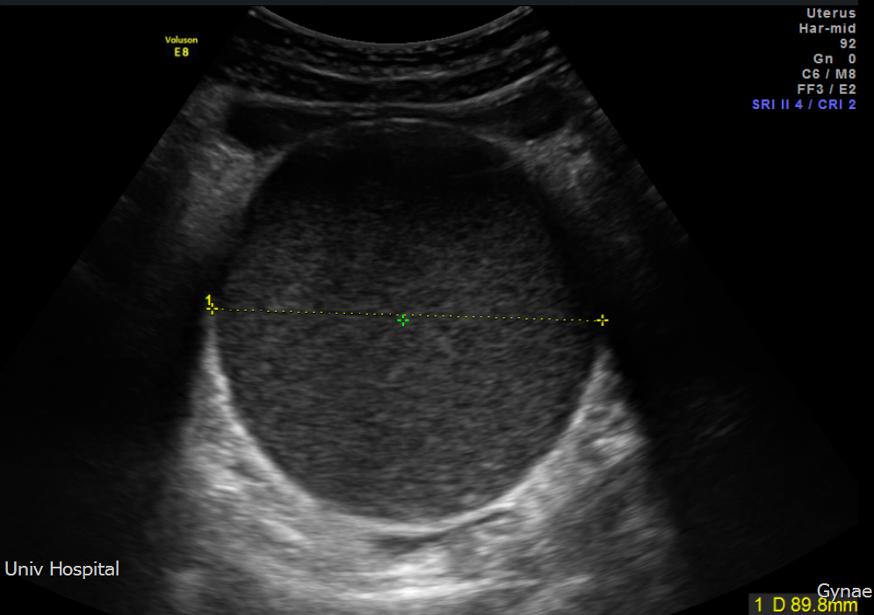 Haematocolpos Transverse view
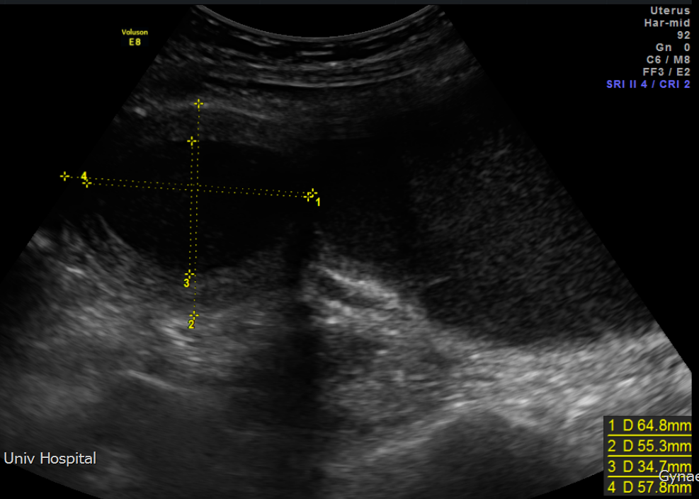 Haematometra Axial view

